287 begin----
If a variable is defined as a complex type, it will need to be initialized before values can be assigned to it.
如果这个变量定义的是一个复杂类型，它在初始化之前就可以指定值给它。
Its initial value is "null" which has no fields. A good way to achieve initialization is to check the has default check box in the data type definition.
如果他的值是空，没有字段，有一个好的方式检查它是否初始化，检查定义数据类型边上的默认值的多选框是否勾上。
Variable identity and UUID
变量特征和UUID
Imagine you create a new Business Object type called "MyBO". What is the identity of that Business Object type?
假设你创建一个新的业务对象的类型为”MyBO” 。那么什么才是这个业务对象的类型的特征？
As you might imagine, there is more to this simple question than meets the eye.
如你所想，这个看似简单的问题，其实很繁琐
The normal way of thinking is that if I create a data type called "X" then it has an identity of "X".
按照通常的思维，如果我创建一个数据类型为“X”，那么我们会认为它的特征就是“X”。
Unfortunately, IBM BPM doesn't think that way. Internally within the heart of the product,
all artifacts (including all data types) are given a generated UUID value. It is this opaque UUID
that the product uses to track references to data types.
很不幸的是，IBM BPM并没有如我们想象的一样，在产品的内部核心中所有的部件（包括所有数据类型）都会生成独一无二的UUID值。
正是这种不可见的UUID值，产品使用它来进行跟踪引用数据类型。
To illustrate, consider the following Human Service definition which has an output parameter called "myBO" of data type "MyBO":
为了说明这一点，给下面的人工服务定义一个名为“myBO”的输出参数，它的类型为“MyBO”

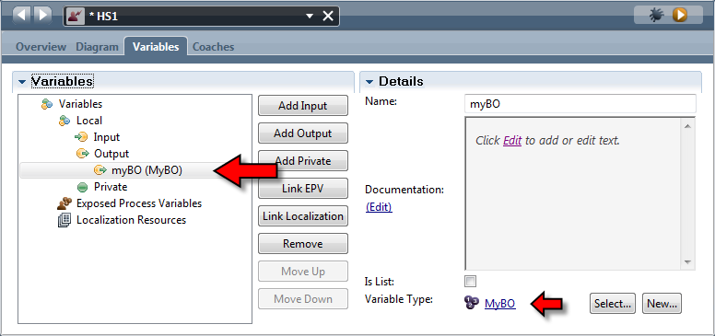
The Human Service definition (called HS1) can be read as:
"This service returns an output called 'myBO' of type 'MyBO'".
However, this is only an illusion. The way the product really thinks of this is:
"This service returns an output called 'myBO' of type
'guid:7b9691c16dd21a42:1e6925ca:142dd70d25a:-7ffa'"
Hmm. That is quite a difference. If we switch on advanced mode in PD and then look at the
definition of the business object, we can see that UUID there:
这个人工服务（名为：HS1）可以理解为：
“这个人工服务返回一个名为‘myBO’类型为‘MyBO’的输出参数”
然而这是一个错觉，产品真正的思维方式是：
“这个人工服务返回一个名为’myBO’类型为'guid:7b9691c16dd21a42:1e6925ca:142dd70d25a:-7ffa'的输出参数”
恩，这是相当不同的，如果我们在PD里打开高级模式，然后看看业务对象的定义，我们能看到它的UUID在那里。
287 end-------
288 start-------

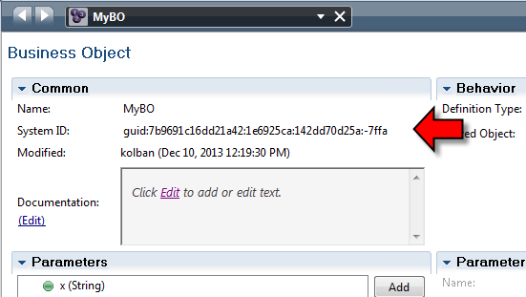
Normally, I wouldn't try and uncover internals knowledge such as this as it is usually irrelevant to
the model and used of the BPM product itself however, there are some ugly ramifications associated
with this implementation story.
正常情况下，我不会尝试去发现内部结构与知识等，这通常是无关紧要的模型和BPM产品本身的东西，不过有一些不好的影响与现实的故事。
As a thought process, consider the following:
1. Create a new Business Object type called MyBO
2. Create a Human Service that returns a variable of type MyBO
3. Delete the Business Object type called MyBO
4. Create a new Business Object type called MyBO identical in structure to the first
模拟一个思考过程，考虑一下几点:
1.创建一个新的业务对象类型名为MyBO。
2.创建一个新的人工服务返回一个类型为MyBO的变量。
3.删除MyBO这个业务对象类型。
4.创建一个新的业务逻辑类型名为MyBO与第一次的结构相同。
Are we now consistent? It would seem so, we have a business object called MyBO which contains all the fields we want. Unfortunately, we are broken.
当前的MyBO与之前的MyBO是一致的么? 似乎是这样的，我们有一个业务逻辑对象MyBO其中包含所有想要的字段，不幸的是，我们都想错了。
In step 2, when we create a Human Service that returned a variable of type MyBO, the Human
Service actually defined that it returned a data type of a UUID. That UUID was associated with the
data type created in step 1. When we performed step 4, a brand new UUID data type was created
that is not the same as that of step 1.
在第二步的时候，我们创建一个人工服务，它返回了一个类型为MyBO的变量，实际上人工服务定义的返回数据类型是一个UUID .那个UUID相关的数据类型是在第一步中创建的。然后我们执行第4步 ， 一个全新的UUID数据类型的创建与第一步是不一样的。
We end up with the Human Service error showing:
最终我们的人工服务上会显示错误:
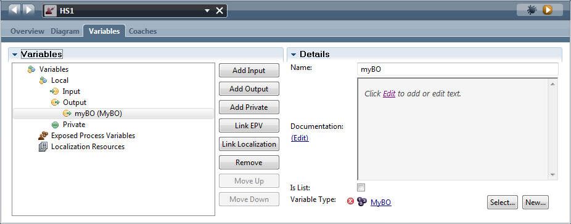
If we hovered over the error we would see:
如果我们查看这个错误我们会看到:
288 end ----
289 start ----
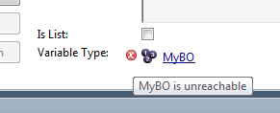
But yet if we examined the list of data types, we would see that MyBO is a defined data type.
The fix would be to remap the variable type to the new MyBO definition. To most folks (including
myself) this is an odd situation to be in.
The moral of the story is to be very careful with the concept of deleting and recreating data types.
Deleting something and then recreating it is not the same as modifying it. This story also comes
into play when you think that you can move data types into toolkits.
但是如果我们检查数据类型的列表，我们将看到这个那个MyBO 是一个已经定义的数据类型。
解决办法是重新映射这个变量类型为新定义的MyBO类型。对于大多数人来说（包括我自己）这是个奇怪的情况。
这则故事的寓意是要非常小心删除和重新创建数据类型的概念。
删除数据类型然后重新创建它并不等同于修改它，当你认为你可以移动数据类型到toolkits的时候也可以参考这个故事。
Exposing Business Data for Searches
暴露业务数据到Search功能
Imagine that we have hundreds (perhaps thousands) of process instances running handling orders
for customers. If a customer calls in and asks "What is the status of my order #1234?" how can we
find the process associated with this?
假设我们有为数百（也许成千上万）的流程实例运行为客户处理订单,如果客户打电话过来问“我的订单#1234的状态是什么？”
我们怎么样才能找到与这相关的流程实例？
When process variables are defined in IBPM, we have an opportunity to flag them as being
available in Business Data Searches. This means that we can execute searches using the exposed
names and values of variables in a process. For example, if a process has a variable called
"orderNumber" and we exposed that for searching, we can now execute a search for process
instances where "orderNumber = 1234".
当在IBPM中定义流程变量的时候，我们有机会标记它们,使得它们可以在业务数据中被搜索到。
这意味着我们可以使用执行搜索找到过程中暴露出的变量名称和值.
例如,如果一个流程有一个名为“orderNumber”的变量并且我们将它暴露到search功能 ,那么我们现在可以执行一个流程实例的search功能，条件为"orderNumber = 1234"。
289 end-----

290 start-----
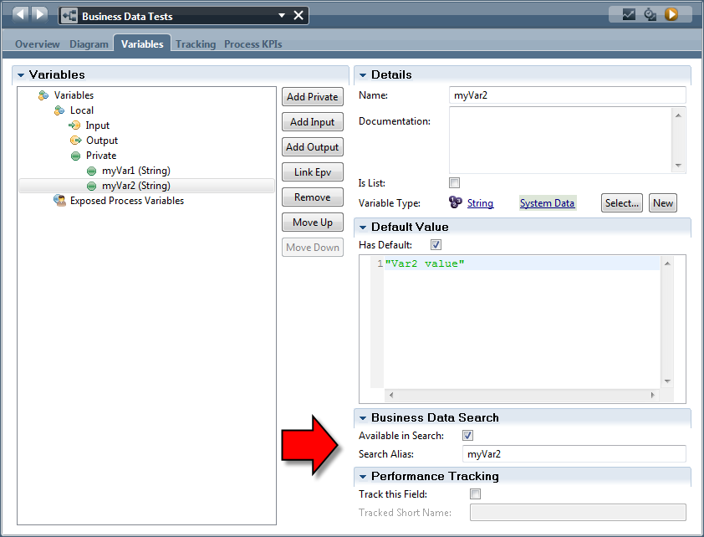
Accessing variables from JavaScript
访问来自JavaScript的变量
It is common to want to read or write the values of variables from within a JavaScript environment.
When a variable is defined at the BPD or service level, it is available within that BPD or service
within the JavaScript scope of:
tw.local.*
通常想要读取或写入在一个JavaScript环境中的变量的值的时候。
当一个变量定义在BPD或服务级别，它在BPD或服务里面的JavaScript范围里是可见的：
通过tw.local.*取得可见变量。

The IBPM PD commonly provides entry assist to show you the names of the in-scope variables that
can be used in a JavaScript fragment. Note that the entry assistance accessed by CTRL+Space in
the editor can be used to substitute the characters "twl" for the string "tw.local.".
IBPM PD 通常提供入口帮助向您展示JavaScript环境里的作用范围内变量的名称 。
注意，在编辑器中可以使用 替代字符串’twl‘得到“tw.local”输入联想通过CTRL+Space访问 .

List variables can be accessed using square bracket notation with an index value starting at 0.
When assigning to a list, if an index value is used that is greater than the size of the list, this is
acceptable. To make this clear, imagine a list with two existing entries which would be [0] and
[1]. If we assign to the list with an index of [3], this would produce an entry for [2] of data
type ANY and no value.
如果变量是一个集合，那么我们可以通过方括号访问索引值从0开始。
当我们访问一个集合的时候，如果它的索引值大于这个集合的大小，这是可以接受的。
详细的说，想象一下一个集合里有下标为[0]和[1]两个元素,如果我们指定一个索引为[3]的话，那么它将产生一个索引为[2]的元素，这个元素的数据类型为ANY并且它是无任何值的。
290 end-----

